# Sign Language to Word Converter

By

[Vivekananda Reddy](mailto:ch.vivekanandareddy2002@gmail.com)

Yashwanth Singh

Prashant Yadav

Lakshya Tyagi

Tanishq panwar

## Abstract

The Sign Language to Word Text Converter represents an initiative facilitating communication between individuals proficient in sign language and those relying on written or spoken language Using advanced technologies such as computer vision and natural language processing, this system interprets sign language gestures in real-time and converts them into corresponding written text The primary goal is to bridge the communication gap, ensuring inclusivity and accessibility for sign language users in various settings This abstract provides an overview of the project's motivation, objectives, technological foundations, and potential impact on fostering a more inclusive society The Sign Language to Word Text Converter signifies a significant advancement in breaking down communication barriers and promoting understanding among diverse communities.

## Introduction

Imagine living in a world where communication is not limited by language barriers. That's the vision behind our Sign Language to Word Converter project. As students passionate about technology and inclusivity, we embarked on this journey to create a tool that bridges the gap between sign language users and those who might not understand sign language.

Turning sign language into words isn't just about making communication easier for individuals; it's about making sure everyone can be a part of society. Research by Huenerfauth shows that this technology can have a big impact on education, jobs, and accessibility. It's a reminder that we need to design these tools with the people who will use them in mind.

Recently, we've seen a lot of progress thanks to deep learning. Think of it as teaching computers to understand sign language better. Researchers like Lewicki and Hochreiter have shown us that using things called recurrent neural networks can help capture the flow of sign language, making recognition more recognition more accurate.

Sign language is incredible—it's a unique form of expression for millions of people worldwide. However, it comes with its challenges, especially when communicating with those unfamiliar with signing. We wanted to address this challenge and make communication more accessible for everyone

Our main goal? Develop a Sign Language to Word Converter—a smart tool that translates sign language gestures into written words. This isn't just about technology, it's about building connections and fostering understanding.

## Proposed Methods:

## Data Collection:

* **Video Datasets:** Often, data for sign language translation is collected through video recordings of signers performing gestures or phrases in sign language.
* **Annotations:** These videos are annotated with information about the sign language gestures being performed. Annotations may include information about the signs, such as hand positions. We had takes the frames and gave them the annotations of our hand.
* **Diversity in Data:** Collecting data from a diverse set of signers is crucial. Variations in sign language exist across regions and among individuals, so a diverse dataset helps improve the accuracy and robustness of the model which we will be doing in future to improve the Model accuracy.
* **Dynamic and Static Gestures:** Included both dynamic gestures for animated signs and static gestures for postural expressions, covering the full spectrum of sign language communication.

## Data Processing:

* **Preprocessing:** Videos need to be processed to extract relevant information. This could involve techniques like frame extraction, where individual frames are isolated from the video to focus on the hand gestures or relevant body parts.
* **Feature Extraction:** Features such as hand shape, movement, facial expressions, and body posture need to be extracted from the video frames. This often involves computer vision techniques to identify and track these features across frames.
* **Data Labelling**: An important step involves labelling the extracted features with the corresponding sign language gestures or words. This creates a labelled dataset that the model can learn from during training.
* **Model Training:** Machine learning or deep learning models are then trained using this labelled dataset. Models like Convolutional Neural Networks (CNNs) or Recurrent Neural Networks (RNNs) might be used to learn patterns from the extracted features and predict corresponding text or words.

## Gesture Recognition Techniques:

People have tried different ways to recognize gestures, using cameras or special sensors. Some have even combined these methods to improve accuracy. This mix of approaches is important in making sure the computer can understand sign language well.

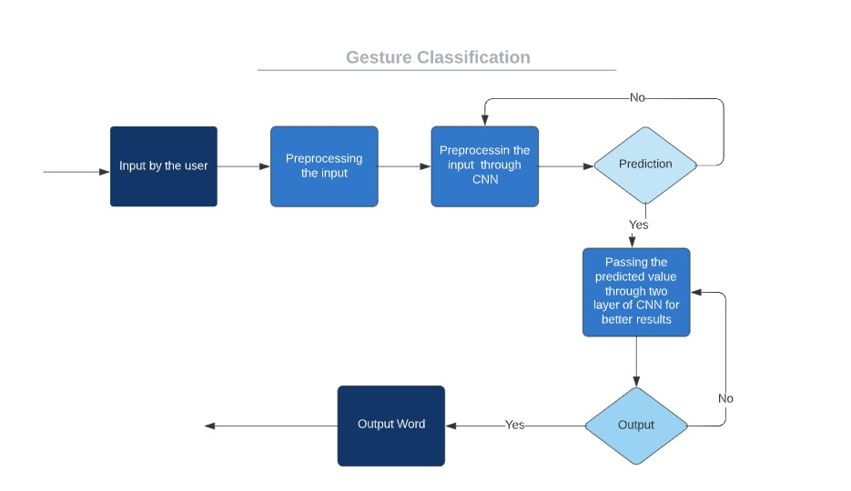

## Challenges and Solutions:

Even with all these cool advancements, there are still challenges. Things like different signing styles, lighting issues, and the need for quick recognition are still tricky. Smart minds, like those of Athitsos and Nevatia, have suggested ways to deal with these challenges, like using smart models and big sets of data to make the system better.

## Applications and Impact:

Turning sign language into words isn't just about making communication easier for individuals; it's about making sure everyone can be a part of society. Research by Huenerfauth shows that this technology can have a big impact on education, jobs, and accessibility. It's a reminder that we need to design these tools with the people who will use them in mind.

# Methodology

**Model Evaluation**

**Convolutional Neural Network (CNN):**

Our decision to use a CNN was motivated by its capacity to capture spatial hierarchies and patterns within images. Given the intricate hand and body movements involved in sign language, CNNs excel at learning hierarchical representations , making them suitable for recognizing these complex gestures. The model architecture encompasses convolutional layers for feature extraction, followed by fully connected layers for classification.

**Criteria for Model Performance:**

Our success criteria for the machine learning model centered around achieving a high overall accuracy. As students committed to creating an impactful project, we aimed for a model that could effectively and consistently recognize a diverse range of sign language gestures. We recognized the importance of a model that generalizes well to new, unseen data, ensuring its practical usability beyond the training set.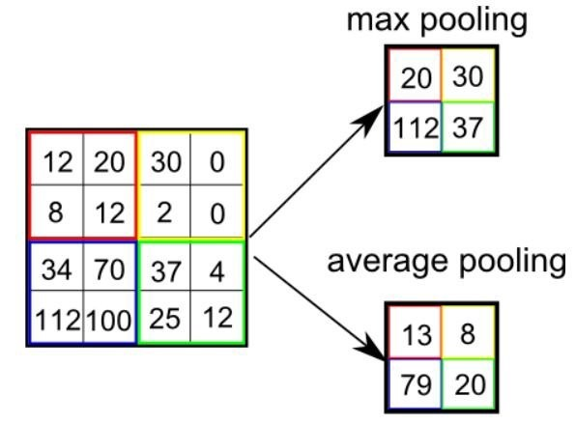

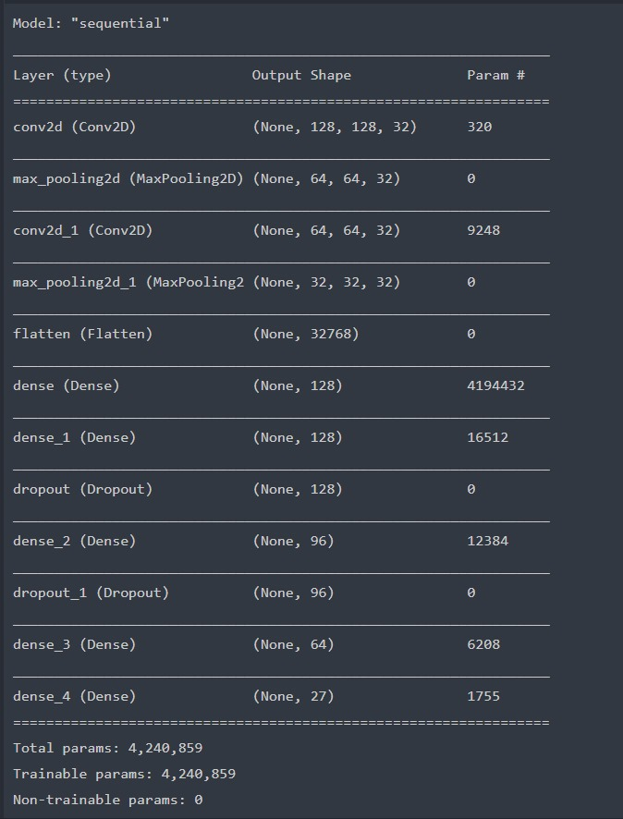

## Design

Outline the overall design of the Sign Language to Word Converter, including architectural decisions and the integration of machine learning components.

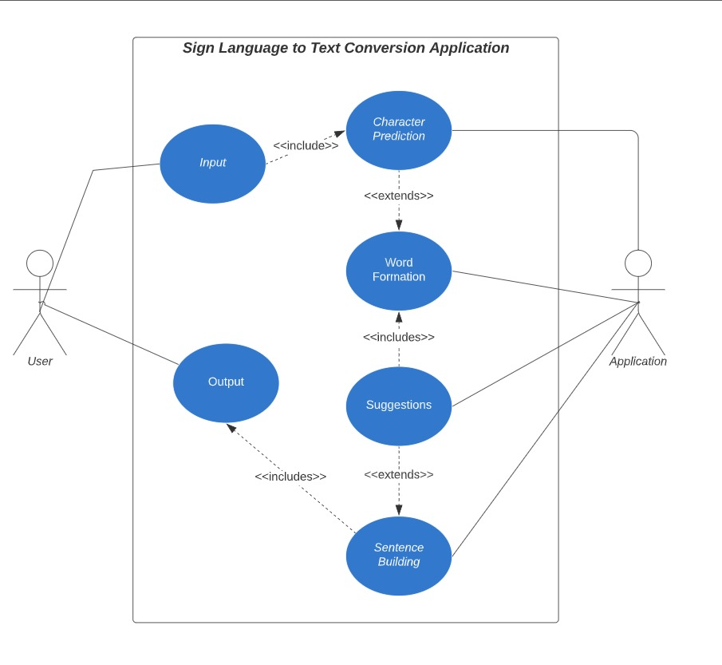

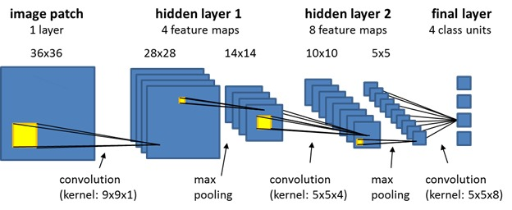

## Testing

The testing strategies employed to validate the functionality and accuracy of the Sign Language to Word Converter.

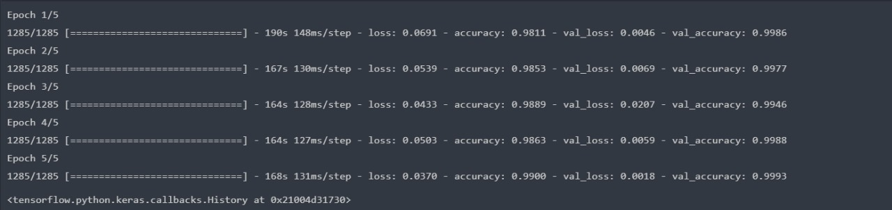

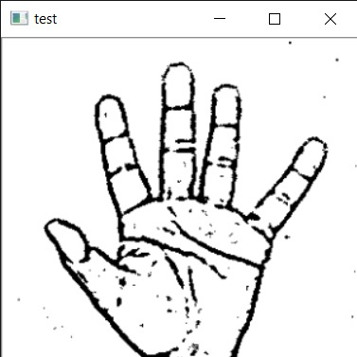

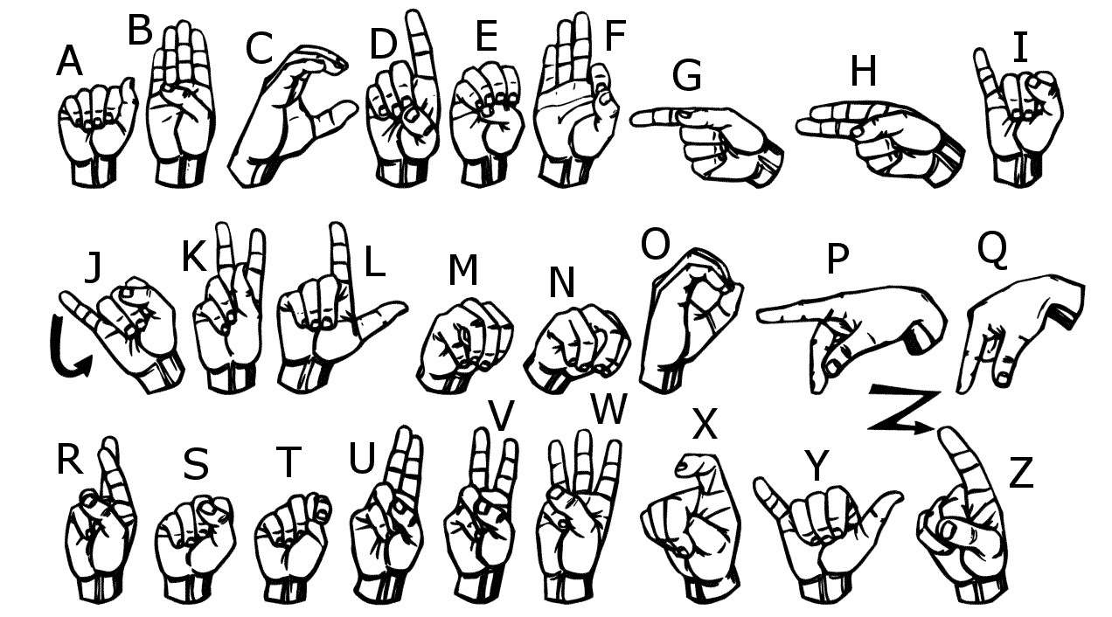

## Conclusion

Sign Language to Word Text Converter project represents a groundbreaking initiative to bridge communication gaps. By utilizing advanced technologies, our innovative solution translates sign language gestures into written words, promoting inclusivity for the deaf and hard-of-hearing community. The diverse dataset, curated with attention to ethical considerations, ensures the model's accuracy and cultural sensitivity. Beyond facilitating everyday conversations, this technological breakthrough has the potential to empower sign language users in education, employment, and societal engagement. Reflection on this journey emphasizes our commitment to continuous improvement, community engagement, and ethical development. The Sign Language to Word Text Converter is more than a technological achievement; it signifies progress toward a more connected and accessible world, where communication barriers are dismantled, and the beauty of sign language seamlessly integrates into the broader linguistic landscape. We are also looking for further improvements to make the model more accurate with less time.

## References

* [SIGN LANGUAGE RECOGNITION: STATE OF THE ART Ashok K Sahoo, Gouri Sankar Mishra and Kiran Kumar RavulakolluDepartment of Computer Science and Engineering, Sharda University, Greater Noida, India](https://www.researchgate.net/publication/262187093_Sign_language_recognition_State_of_the_art)
* [Machine learning methods for sign language recognition: A critical review and analysis I.A. Adeyanjua , O.O. Bello b , M.A. Adegboye](https://www.sciencedirect.com/science/article/pii/S2667305321000454)
* [Real time conversion of sign language to speech and prediction of gestures using Artificial Neural Network panelAbey Abraham, V Rohini](https://www.sciencedirect.com/science/article/pii/S1877050918321331)
* [Selfie video based continuous Indian sign language recognition system Ananth Rao a, P.V.V. Kishore](https://www.sciencedirect.com/science/article/pii/S2090447917300217)
* [A Deep Convolutional Neural Network Approach for Static Hand Gesture Recognition Adithya V.](https://www.sciencedirect.com/science/article/pii/S1877050920312473)
* [A comprehensive evaluation of deep models and optimizers for Indian sign language recognition by Prachi](https://www.sciencedirect.com/science/article/pii/S2666629421000152)